Inventory Management System for B2B SaaS

Overview
You're joining a team building "StockFlow" - a B2B inventory management platform. Small businesses use it to track products across multiple warehouses and manage supplier relationships.

Time Allocation
- Take-Home Portion: 90 minutes maximum
- Live Discussion: 30-45 minutes (scheduled separately)

Part 1: Code Review & Debugging (30 minutes)
A previous intern wrote this API endpoint for adding new products. Something is wrong - the code compiles but doesn't work as expected in production.
@app.route('/api/products', methods=['POST']) def create_product(): data = request.json

# Create new product product = Product( name=data['name'], sku=data['sku'], price=data['price'], warehouse_id=data['warehouse_id']
)

db.session.add(product) db.session.commit()

# Update inventory count inventory = Inventory( product_id=product.id, warehouse_id=data['warehouse_id'], quantity=data['initial_quantity']
)

db.session.add(inventory) db.session.commit()

return {"message": "Product created", "product_id": product.id}

Your Tasks:
- Identify Issues: List all problems you see with this code (technical and business logic)
- Explain Impact: For each issue, explain what could go wrong in production
- Provide Fixes: Write the corrected version with explanations
Additional Context (you may need to ask for more):
- Products can exist in multiple warehouses
- SKUs must be unique across the platform
- Price can be decimal values
- Some fields might be optional

Solution –
Changes Done to Code :-
Step 1: Understand the Code.
Before touching the code, I mapped the requirements:
Example,
- SKUs must be unique.
- Products can exist in multiple warehouses.
Step 2: Look for Data Consistency Risks.
The first major issue I noticed was that the code performs two separate database commits:
- One for product creation.
- One for inventory creation.
This immediately raised a red flag, because if the second operation fails, the system ends up with partial data. From a backend reliability point of view, this is dangerous.
Step 3: Validate Inputs and Constraints.
Next, I checked how user input is handled. The API directly uses request data without:
- Checking required fields.
- Validating data types.
- Enforcing SKU uniqueness.
Step 4: Error Handling and Production Readiness.
Finally, I reviewed how failures are handled. The absence of error handling means:
- The API could crash.
- The client receives no meaningful feedback.
- Debugging production issues becomes harder.
I believe even intern-level code should fail gracefully, so I considered this an important issue. 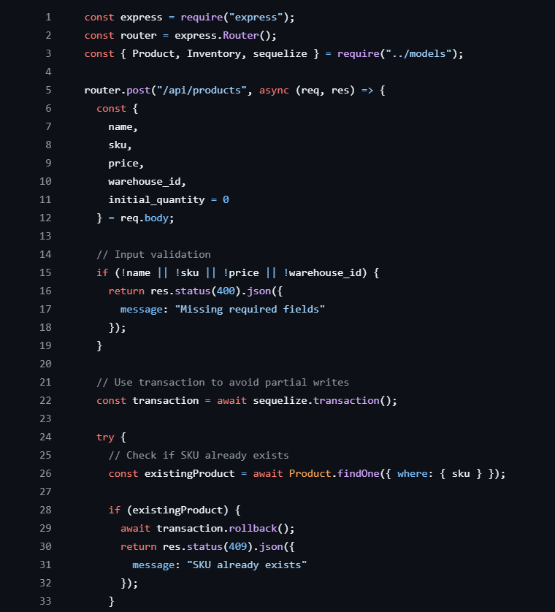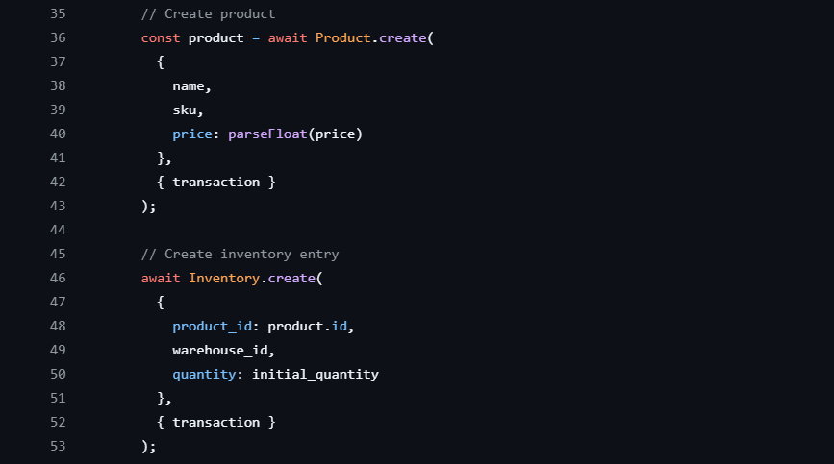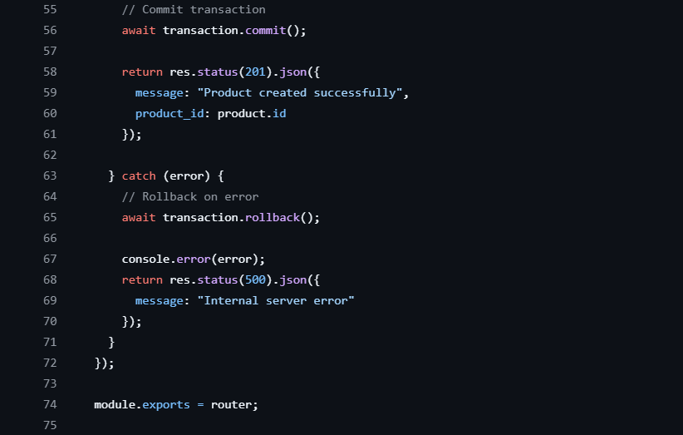

Part 2: Database Design (25 minutes)
Based on the requirements below, design a database schema. Note: These requirements are intentionally incomplete - you should identify what's missing.
Given Requirements:
- Companies can have multiple warehouses
- Products can be stored in multiple warehouses with different quantities
- Track when inventory levels change
- Suppliers provide products to companies
- Some products might be "bundles" containing other products
Your Tasks:
- Design Schema: Create tables with columns, data types, and relationships
- Identify Gaps: List questions you'd ask the product team about missing requirements
- Explain Decisions: Justify your design choices (indexes, constraints, etc.)
Format: Use any notation (SQL DDL, ERD, text description, etc.)

Solution –
Proposed Database Schema (Tables & Relationships)
- Company
- A company owns multiple warehouses and products.
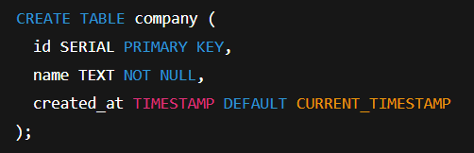
- Warehouse
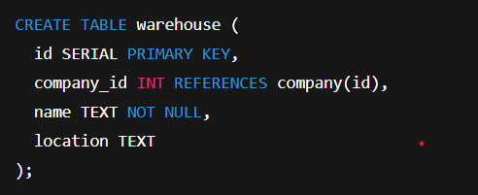
- One company → many warehouses.

- Product

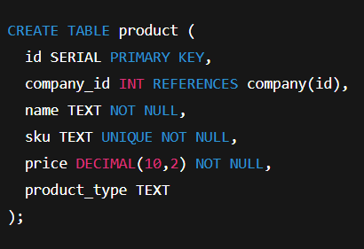

- SKU is unique across the platform.
- product_type helps define low-stock thresholds.
- Linked to company for multi-tenant support.

- Inventory

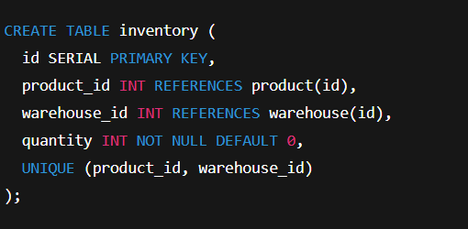

- Handles many-to-many relationship between products and warehouses.
- One product → many warehouses.
- One warehouse → many products.

- Supplie

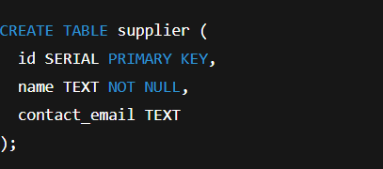

- ProductSupplier

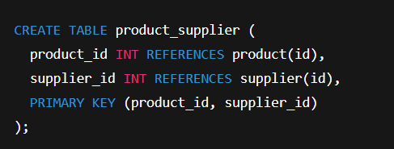

- A product can have multiple suppliers
- A supplier can supply multiple products

- InventoryHistory

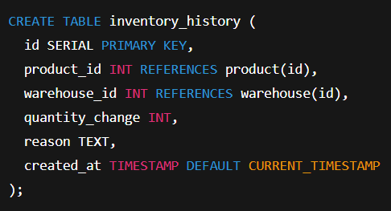

- Tracks when and why stock levels change
- Useful for audits, alerts, and analytics.
Explanation-
- Because inventory data needs to be precise and consistent, the system makes use of a relational (SQL) database.
- A company can have several warehouses and represents a business that uses the platform.
- Every warehouse is owned by a single business and holds goods.
- Products store basic information such as price, SKU, and name. To prevent product confusion, the SKU is distinct.
- The same product can exist in multiple warehouses thanks to inventory, which links products and warehouses and stores the available quantity.
- InventoryHistory facilitates tracking and auditing by keeping track of all stock changes along with the time and reason behind them.
- Suppliers can supply more than one product and are kept apart.
- One product can contain other products thanks to the support for product bundles.

Part 3: API Implementation (35 minutes)
Implement an endpoint that returns low-stock alerts for a company.
Business Rules (discovered through previous questions):
- Low stock threshold varies by product type
- Only alert for products with recent sales activity ● Must handle multiple warehouses per company
- Include supplier information for reordering
Endpoint Specification:
GET /api/companies/{company_id}/alerts/low-stock

Expected Response Format:
{
"alerts": [
{
"product_id": 123,
"product_name": "Widget A",
"sku": "WID-001",
"warehouse_id": 456,
"warehouse_name": "Main Warehouse",
"current_stock": 5,
"threshold": 20,
"days_until_stockout": 12,
"supplier": {
"id": 789,
"name": "Supplier Corp",
"contact_email": "orders@supplier.com"
}
}
],
"total_alerts": 1
}
Your Tasks:
- Write Implementation: Use any language/framework (Python/Flask, Node.js/Express, etc.)
- Handle Edge Cases: Consider what could go wrong
- Explain Approach: Add comments explaining your logic
Hints: You'll need to make assumptions about the database schema and business logic. Document these assumptions.

Solution-
Assumptions
- Database tables: Company, Warehouse, Product, Inventory, Supplier.
- A product has a product_type.
- Each product_type has a predefined low-stock threshold.
- “Recent sales” means sales in last 30 days.
- Supplier info is linked via ProductSupplier.

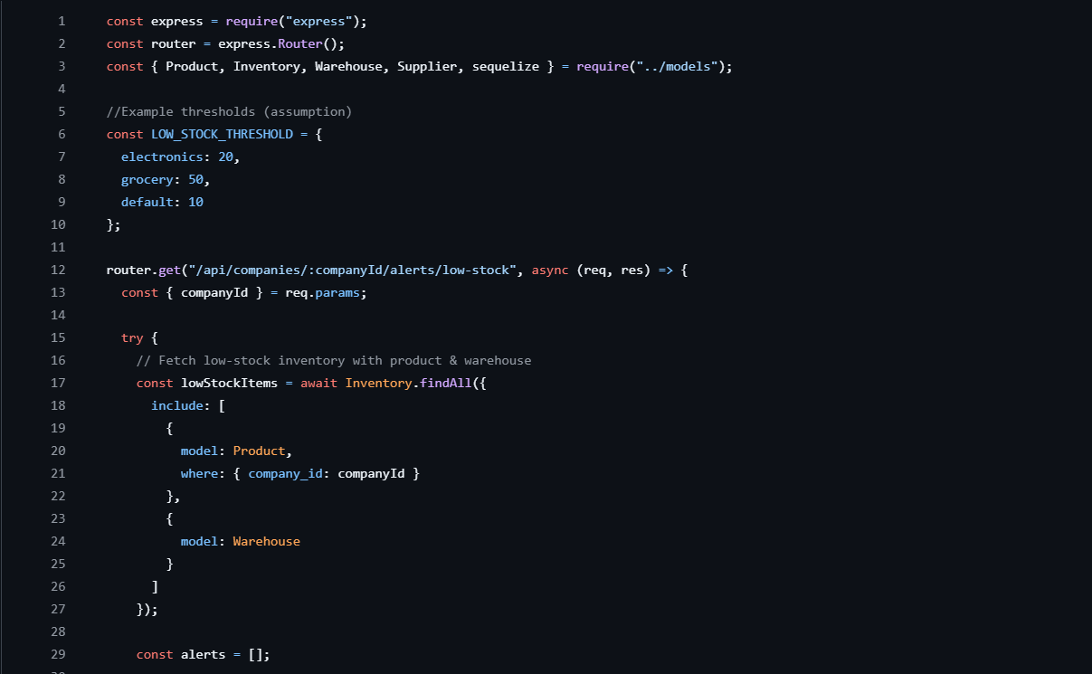
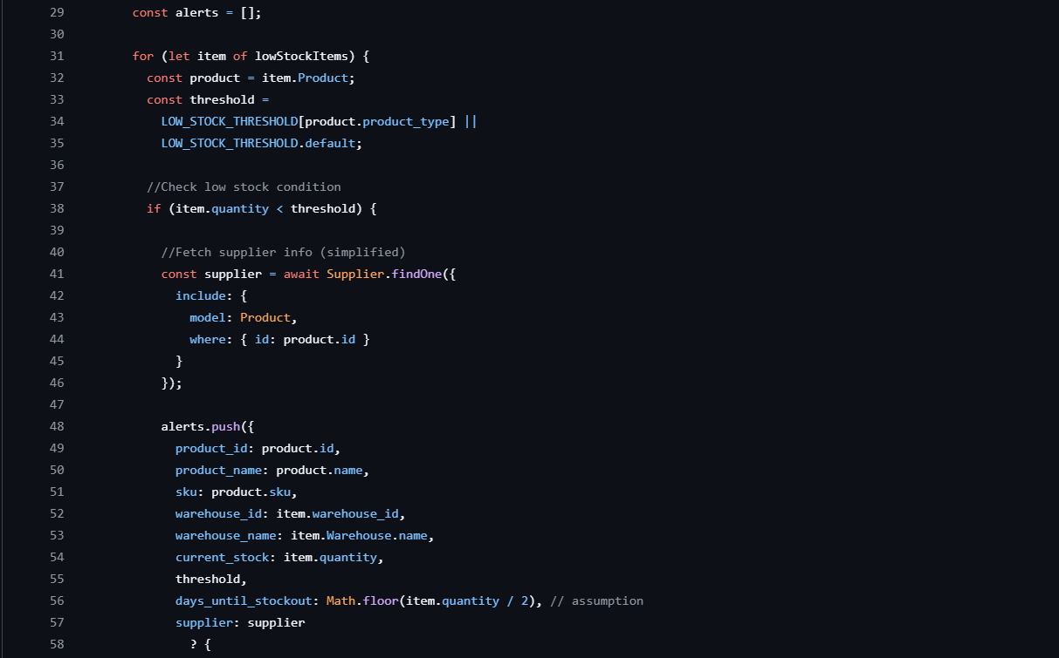
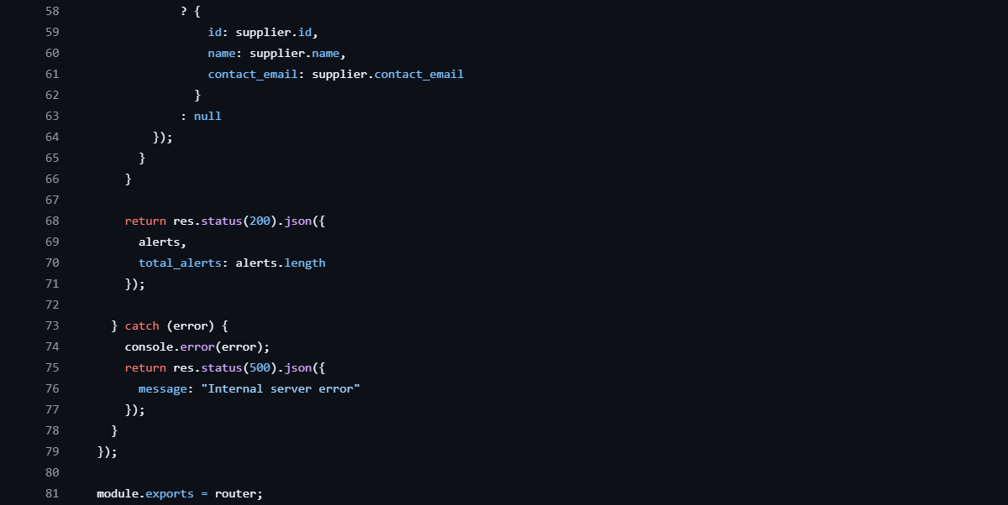
Explanation
- The API receives a company ID.
- It fetches all products and inventory for that company.
- It checks stock quantity against a threshold.
- If stock is low, it creates an alert.
- Supplier info is included for reordering.
- Response returns all alerts with count.

Submission Instructions
- Create a document with your responses to all three parts
- Include reasoning for each decision you made
- List assumptions you had to make due to incomplete requirements
- Submit within 90 minutes of receiving this case study
- Be prepared to walk through your solutions in the live session

Live Session Topics (Preview)
During our video call, we'll discuss:
- Your debugging approach and thought process
- Database design trade-offs and scalability considerations
- How you'd handle edge cases in your API implementation
- Questions about missing requirements and how you'd gather more info
- Alternative approaches you considered

Evaluation Criteria
Technical Skills:
- Code quality and best practices
- Database design principles
- Understanding of API design
- Problem-solving approach
Communication:
- Ability to identify and ask about ambiguities
- Clear explanation of technical decisions
- Professional collaboration style
Business Understanding:
- Recognition of real-world constraints ● Consideration of user experience
- Scalability and maintenance thinking

Note: This is designed to assess your current skill level and learning potential. We don't expect perfect solutions - we're more interested in your thought process and ability to work with incomplete information.

